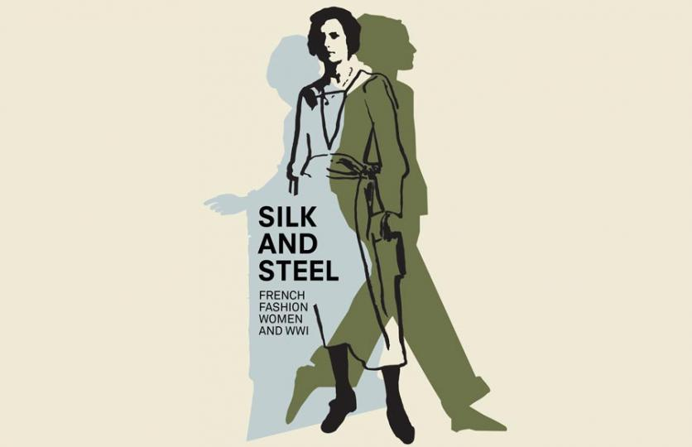

Silk and Steel: French Fashion, Women and WWI
Opening Friday, Sept. 25, 2020
National WWI Museum and Memorial

Short Summary:
WWI exploded in the late summer of 1914 and though underrepresented in the histories, women were working hard in war industries, nursing, transportation and fighting for equal rights. The survival of women’s fashion also played an important role in keeping up morale, maintaining ties with allies and even helping war-time economies, especially in France. From the evolution of the war-time silhouette, the influence of military uniforms and post-war emancipation, Silk and Steel: French Fashion, Women and WWI, provides a new chapter of the history of the war at the Museum and Memorial. Exhibition open Sept. 25, 2020 – April 11, 2021 in the Wylie Gallery.

Full Summary:
“The invincible spirit of France has been nowhere better mobilized that in its brave couture.”
– Women’s Wear Daily, May 1917

WWI exploded in the late summer of 1914. Armies took the field in bright uniforms. Navies steamed to sea flying the colors of their nations. For the ensuing years of global war until the peace treaty was signed on June 28, 1919, most history has centered on battles, leaders and destruction.
Throughout this time, a largely unrepresented population in the histories were women in all belligerent countries during the war. Life went on, deeply affected by loss of loved ones and normal lives, but still with hope for peace. French women, like others, worked in war industries, in agriculture, in nursing, in transport, for suffrage and equal pay and respect. In France, recent scholarship has shown that the survival of women’s fashion also played an important role in keeping up morale, maintaining ties with allies and even helping the war-time economies.
This special exhibition, Silk and Steel: French Fashion, Women and WWI, is presented by the National WWI Museum and Memorial from Sept. 25, 2020 to April 11, 2021 in the Wylie Gallery. A previous iteration, entitled French Fashion–Women, the First World War, was organized in 2019 by the Bard Graduate Center Gallery, N.Y. This exhibition, Silk and Steel: French Fashion, Women and WWI, builds upon the excellent research, graphics and assistance they provided, including most of the large subject and theme labels that have been adapted. The basis for the American projects was the 2017 exhibition Mode & Femmes 14-18 organized by the Bibliothèque Forney, Paris, France. That exhibition was curated by Maude Bass-Krueger and Sophie Kurkdjian.
Silk and Steel features original dresses, coats, capes, hats, shoes and accessories. Topics presented are the evolution of the war-time silhouette, Parisian designers during the war, military uniforms’ influence, women’s uniforms in France and America, war work, economics of fashion and post-war emancipation.
Original clothing and accessories are on loan from the Kansas City Museum; the Western Reserve Historical Society, Cleveland; Missouri Historic Costume and Textile Collection, University of Missouri, Columbia; Kansas State Historical Society, Topeka and the Preservation Society of Newport County, Newport, R.I. Material from the National WWI Museum and Memorial includes clothing, accessories, military uniforms, archival documents, photographs, original posters and French fashion images and periodicals.
Period French designers shown include Callot Sœurs, Madeleine Vionnet, House of Worth, Maison Complier & Rondeau and Hermès.

Images/Captions:

The Women of France, YWCA United War Work Campaign poster

French Army artillery officer's wool dolman style short jacket, 1914

French shell art made from 75mm shell with decoration of fashionable French woman

Dress of gold velvet with metal thread made by Liberty, 3B Des Capucines, Paris, 1920 (Courtesy of Missouri Historic Costume and Textile Collection, University of Missouri)

Color lithograph of French women mourning by Theophile Steinlen

Petit point French evening bag with beaded metal frame and chain link strap (Courtesy of Missouri Historic Costume and Textile Collection, University of Missouri)

Black silk satin and tulle evening dress designed by Madeleine, Paris. (Courtesy of The Preservation Society of Newport County, RI)

