C:\Users\User\Desktop\PR\Прозрачные лого\depkult_gerb.eps**** 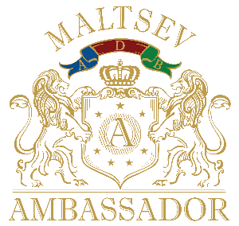

**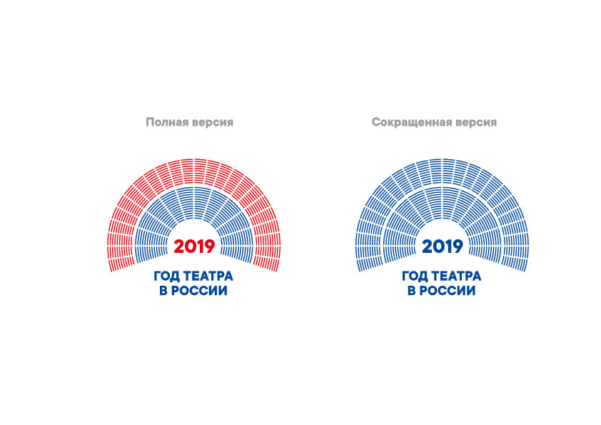**

**Exhibition**

**"RUSSIAN BALLET IS FASHION FOREVER.**

**Painting, graphics, sculpture, decorative-applied art"**

From November 20, 2019 to January2, 2020, the Museum of Fashion Museum will host an exhibition dedicated to the Russian Ballet, an enduring, eternal fashion and cultural treasure of our country.

Ballet has long been a hallmark of Russian art: at the end of the 19th century, the world applauded the Russian ballet corpsenam; in the early 20th century Sergei Diaghilev opened Europe to Pavlov, Nijinsky, Karsavin, Lifar and many other great characters; the Soviet era gave brilliant dancers and choreographers such as Galina Ulanova, Natalia Dudinskaya, Konstantin Sergeev, Olga Lepeshinskaya, Maya Plisetskaya, Ekaterina Maksimova, Vladimir Vasilyev, Rudolf Nureyev, Mikhail Baryshnikov, Yuri Grigorovich, Oleg Vinogradov and many others.

In the new exhibition space of the Fashion Museum there will be zones of imperial theaters, ballet seasons diaghilev, the Soviet period in the history of the national ballet. An excellent artistic dedication to the 30th anniversary of Rudolf Nureyev's visit to the USSR will be an exhibition of works by contemporary artists and sculptors who paid tribute to the talent of one of the greatest dancers of the 20th century. Guests of the exhibition will see a costume presented by Nureyev to his pupil Aidar Akhmetov, as well as original costumes of the most famous ballets of the 20th century.

The exhibition will feature paintings, graphics, sculpture, porcelain, glass works of famous masters of the twentieth century, such as Rehrberg, Benoit, Shoirich, Degas, Matisse, Cocteau, Lifar, Erte, Janson-Manizer, Messerer, Bruni, Time-Block, etc.. . Contemporary art will present no less well-known names of artists and sculptors inspired by ballet and the work of great dancers of the past - Kosorukov, Blokhin, Blokhin, Remev, Фирсов и др.

An interesting artistic and historical block of the exhibition will be sketches of costumes and decorations made by famous artists for ballets. The presence of ballet costumes on mannequins will give reality to images and emphasize the special artistic atmosphere of space. There will be attention and live works made from nature - great dancers in the class. Interior installations of the eras in which the stars of Russian ballet lived, will give atmosphere and color to the project and demonstrate the best examples of antique furniture and objects of decorative and applied art of the 19th - early 20th century, and the presence of ballet costumes and accessories will turn the space of the Fashion Museum into a real ballet festival.

Важной частью проекта "Русский балет — мода навсегда" станет выставка живописных и акварельных работ легендарного танцовщика ХХ века, хореографа, режиссёра, педагога, художника, поэта, народного артиста СССР и РФ Владимира Васильева "Танцующая кисть", приуроченная к его 80-летию.

2020 - anniversary year for many great ballet characters: Galina Ulanova - 110 years, Konstantin Sergeyev - 110, Vakhtang Chabukiani - 110, Alexey Yermolayev - 110, Tatiana Vecheslova - 110, Maya Plisetskaya - 95, Natalia Makarova - 80, Vladimir Vasilyev - 80, Mikhail Fokin - 140, Tamara Karsavina - 135, Ida Rubinstein - 135, Olga Spesivtseva - 125, Leonid Lavrovsky - 115, Mikhail Gabovich - 115, Sofia Golovkin - 105, Vera Volkova - 115, Alicia Alonso - 100. During the exhibition there will be artistic meetings and anniversary evenings, lectures and kuratotours.

As part of the exhibition project, the Russian Post will issue original collectible postcards, which will be solemnly redeemed at the opening of the exhibition in the presence of the first persons of the Department of Culture of the City #ofMoscow, the Russian Post Office and the Moscow Fashion Museum. \_моданавсегда в любую точку мира.

The author and curator of the project is an art historian, master of fine arts and designer-decorator Yuri Maltsev.

On press accreditation and for more information:

PR-Service of the Mvc "Fashion Museum"

Tatiana Nosacheva ( 7 499 270 42 61, 7 909 167 84 77

[fashion-cultsbk.](mailto:fashion-kult@bk.ru) [ru](mailto:fashion-kult@bk.ru)

Partners of the project:

 

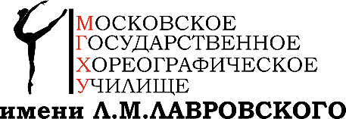 

Information about the Fashion Museum:

The Museum of Fashion is the first museum in Russia dedicated to the study, research and popularization of the history of fashion as an important part and phenomenon of material culture. The Fashion Museum's collection includes dresses, costumes, hats,в. accessories and shoes from the late 19th and 20th centuries and has more than two thousand exhibits.

Сайт музея: **http://fashion-museum.** **ru**

Living Yard, Ilyinka St., 4th Street, entrance from Crystal Lane