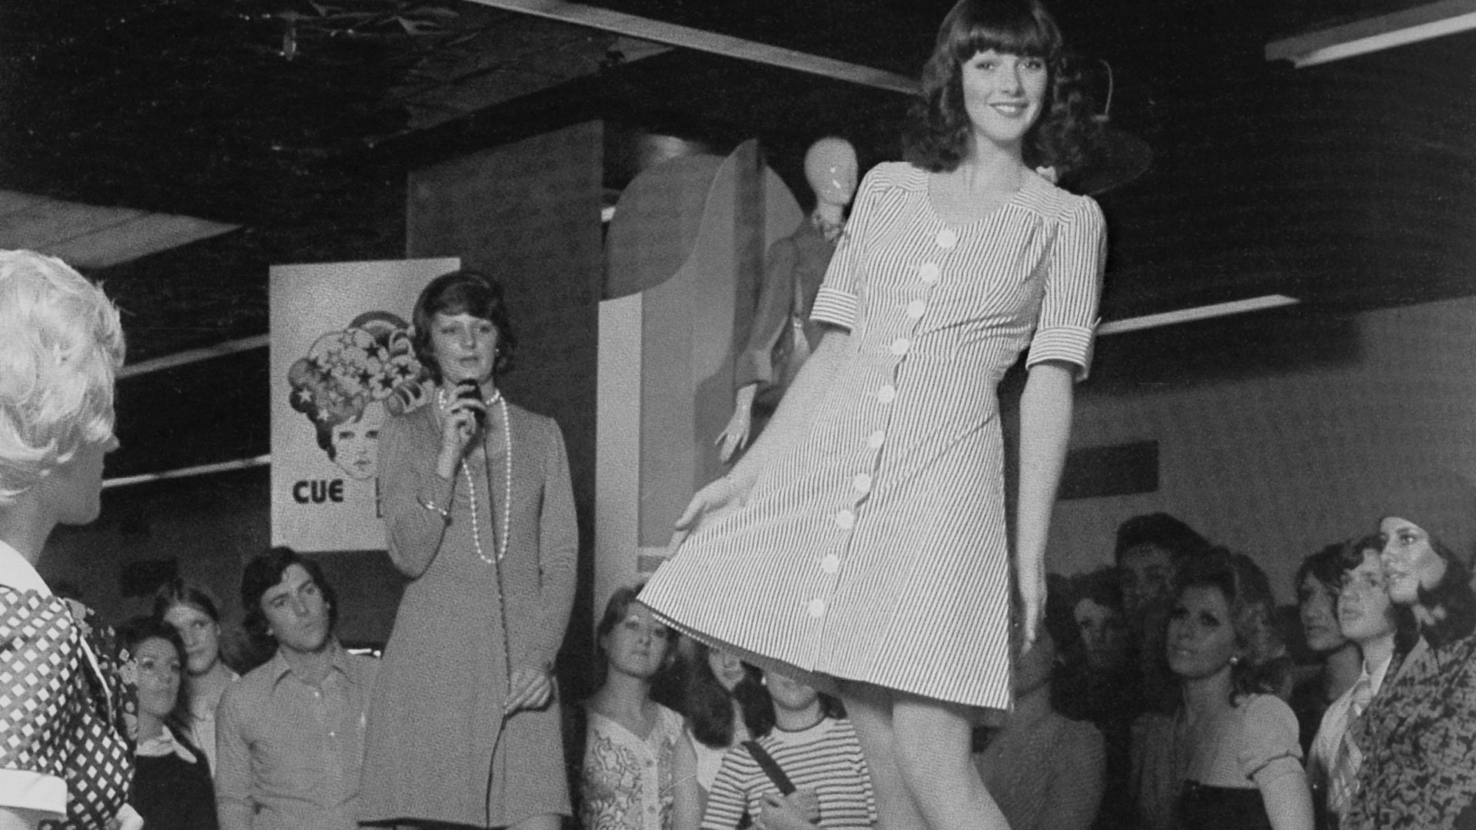
MEDIA RELEASE | 13 NOVEMBER 2019

Image: Cue at Myer summer fashion launch, Melbourne, 1974. Courtesy of Cue.

CUE CELEBRATES 50 YEARS IN FASHION
AT POWERHOUSE MUSEUM

Cue and the Powerhouse Museum today announced Cue: 50 Years of Australian Fashion, the first exhibition to explore the unique story of the loved fashion brand.

Rod Levis AM, established Cue in 1968, inspired by the youth culture of swinging London. From the company’s Sydney Head Office, where it is still based today, Cue has maintained a reputation for delivering modern, design-driven styles for the contemporary woman’s fashion milestones.

Lisa Havilah, Powerhouse Chief Executive said: “Cue is a major, design-led and family-owned Sydney based company. The Powerhouse is excited to be partnering with Cue for this display which tells the story of fashion design and production in Australia.”

Twenty looks from the five decades of Cue’s history will be on display, from strong-shouldered power suits of the 1980s to current outfits from the talented design team. These are exhibited alongside designer illustrations, photographs and advertising material.

Rod Levis, Cue Owner and Founder said: “When I opened our first Cue store with our own branded collection, in the Strand Arcade on 28 November 1968, I could not have envisaged we would be celebrating over 50 years later at the Powerhouse. We are completely humbled that the Powerhouse has chosen to feature Cue’s history of design in this display.

I am especially proud of our past link with the Powerhouse. In 2013 Making it: 20 Years of Student Fashion featured three of our designers’ work. Both Prue Rainey and Lauren Vieyra are with us today as is our associate company‘s Dion Lee – three of the only four students active in design and remaining in Australia.”

Cue: 50 Years of Australian Fashion focuses on the ethos and workings of this family-owned company which is one of the many Australian success stories that form part of the Powerhouse’s permanent collection.

Cue: 50 Years of Australian Fashion opens on 29 November 2019 until 26 April 2020.

MEDIA CONTACTS

E: marketing@cue.cc

E: tara.riley@cue.cc

P: 02 8235 2482

